WEEK 3
MODULE 7 - SPRING REST USING SPRING BOOT 3
3.spring-rest-handson

NAME : ANANTH KARTHIK V
SUPERSET ID : 6738185

OBJECTIVE:
To demonstrate the integration of a RESTful Web Service of type GET and test the service using Postman.
RESTful Web Service Architecture
A RESTful Web Service follows a layered architecture consisting of:
1. Controller Layer
- Acts as the entry point for client requests.
- Receives HTTP requests and sends responses.
- Maps URLs to appropriate service methods.
- Handles communication between the client and the application.
2. Service Layer
- Contains the business logic of the application.
- Processes requests received from the Controller.
- Performs validations and computations if required.
- Communicates with the DAO layer to retrieve or manipulate data.
3. DAO (Data Access Object) Layer
- Responsible for data access operations.
- Interacts with the database to fetch or store data.
- Separates database logic from business logic.
GET Method in RESTful Web Services
- The GET method is used to retrieve data from the server.
- It is a read-only operation and does not modify existing data.
- The requested resource is identified using a URL.
- The server processes the request and returns the required information, usually in JSON or XML format.
Testing GET Service Using Postman
Postman is a popular API testing tool used to send HTTP requests and verify responses.
Steps:
- Open Postman.
- Select the GET request method.
- Enter the API endpoint URL.
- Click the Send button.
- Observe the response returned by the server.
- Verify the status code, response body, and headers.
Advantages of RESTful Web Services
- Simple and lightweight architecture.
- Platform and language independent.
- Uses standard HTTP protocols.
- Supports multiple data formats such as JSON and XML.
- Easy to develop, maintain, and test.
- Improves interoperability between different applications.
Conclusion
RESTful Web Services use a layered architecture consisting of Controller, Service, and DAO layers. The GET method is used to retrieve data from the server, and tools like Postman help test and validate the service responses efficiently.

EXERCISES :
- Problem Statement - Display Employee List and Edit Employee form using RESTful Web Service
Solution:
Employee.java:
package com.example.employeeapi.model;
public class Employee {
private int id;
private String name;
private String department;
public int getId() { return id; }
public void setId(int id) { this.id = id; }
public String getName() { return name; }
public void setName(String name) { this.name = name; }
public String getDepartment() { return department; }
public void setDepartment(String department) { this.department = department; }
}
employees.xml:
<beans xmlns="http://www.springframework.org/schema/beans"
xmlns:xsi="http://www.w3.org/2001/XMLSchema-instance"
xsi:schemaLocation="http://www.springframework.org/schema/beans
http://www.springframework.org/schema/beans/spring-beans.xsd">
<bean id="employeeList" class="java.util.ArrayList">
<constructor-arg>
<list>
<bean class="com.example.employeeapi.model.Employee">
<property name="id" value="02"/>
<property name="name" value="Ananth"/>
<property name="department" value="Gold Loan"/>
</bean>
<bean class="com.example.employeeapi.model.Employee">
<property name="id" value="02"/>
<property name="name" value=" Karthik "/>
<property name="department" value="Finance"/>
</bean>
<bean class="com.example.employeeapi.model.Employee">
<property name="id" value="03"/>
<property name="name" value="Jana"/>
<property name="department" value="Cashier"/>
</bean>
</list>
</constructor-arg>
</bean>
</beans>
EmployeeService.java:
package com.example.employeeapi.service;
import com.example.employeeapi.model.Employee;
import org.springframework.stereotype.Service;
import org.springframework.context.support.ClassPathXmlApplicationContext;
import java.util.List;
@Service
public class EmployeeService {
public List<Employee> getAllEmployees() {
ClassPathXmlApplicationContext context = new ClassPathXmlApplicationContext("employees.xml");
return (List<Employee>) context.getBean("employeeList");
}
public Employee getEmployeeById(int id) {
return getAllEmployees()
.stream()
.filter(e -> e.getId() == id)
.findFirst()
.orElse(null);
}
}
EmployeeController.java:
package com.example.employeeapi.controller;
import com.example.employeeapi.model.Employee;
import com.example.employeeapi.service.EmployeeService;
import org.springframework.web.bind.annotation.*;
import org.springframework.beans.factory.annotation.Autowired;
import java.util.List;
@RestController
@RequestMapping("/api/employees")
@CrossOrigin(origins = "*") // Optional: allow access from frontend
public class EmployeeController {
@Autowired
private EmployeeService employeeService;
@GetMapping
public List<Employee> getAll() {
return employeeService.getAllEmployees();
}
@GetMapping("/{id}")
public Employee getById(@PathVariable int id) {
return employeeService.getEmployeeById(id);
}
}

Output:
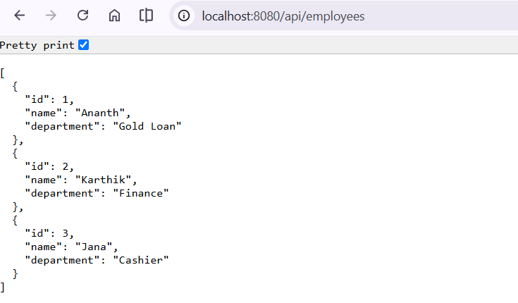

- Create static employee list data using spring xml configuration
Solution:
EmployeeController.java:
package com.example.employee_api.controller;
import com.example.employee_api.model.Employee;
import com.example.employee_api.service.EmployeeService;
import org.springframework.web.bind.annotation.*;
import org.springframework.beans.factory.annotation.Autowired;
import java.util.List;
@RestController
@RequestMapping("/api/employees")
@CrossOrigin(origins = "*") // Optional: allow access from frontend
public class EmployeeController {
@Autowired
private EmployeeService employeeService;
@GetMapping
public List<Employee> getAll() {
return employeeService.getAllEmployees();
}
@GetMapping("/{id}")
public Employee getById(@PathVariable int id) {
return employeeService.getEmployeeById(id);
}
}
EmployeeDao.java:
package com.example.employee_api.dao;
import com.example.employee_api.model.Employee;
import org.springframework.context.support.ClassPathXmlApplicationContext;
import org.springframework.stereotype.Repository;
import java.util.ArrayList;
import java.util.List;
@Repository
public class EmployeeDao {
public static List<Employee> EMPLOYEE_LIST = new ArrayList<>();
public EmployeeDao() {
try {
ClassPathXmlApplicationContext context =
new ClassPathXmlApplicationContext("employee.xml");
EMPLOYEE_LIST = (List<Employee>) context.getBean("employeeList");
System.out.println(">>> Loaded employees from XML: " + EMPLOYEE_LIST.size());
} catch (Exception e) {
e.printStackTrace();
}
}
public List<Employee> getAllEmployees() {
return EMPLOYEE_LIST;
}
}

Employee.java:
package com.example.employee_api.model;
import java.util.List;
public class Employee {
private int id;
private String name;
private String department;
private List<String> skills;
public Employee() {}
public int getId() { return id; }
public void setId(int id) { this.id = id; }
public String getName() { return name; }
public void setName(String name) { this.name = name; }
public String getDepartment() { return department; }
public void setDepartment(String department) { this.department = department; }
public List<String> getSkills() { return skills; }
public void setSkills(List<String> skills) { this.skills = skills; }
}
Output:
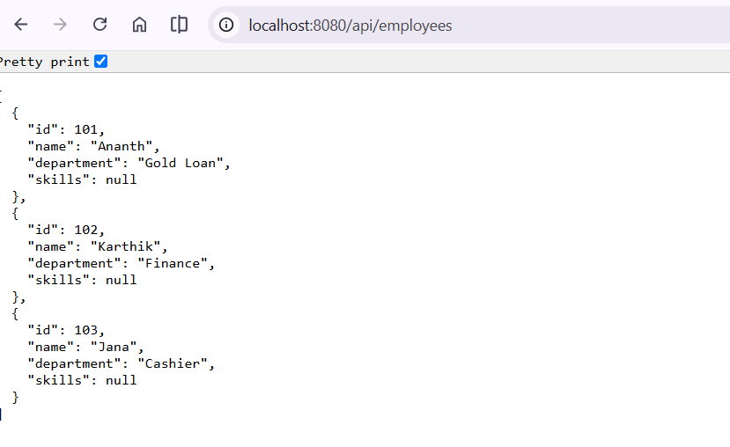

- Create REST service to gets all employees
Solution:
EmployeeController.java:
package com.example.employee_api.controller;
import com.example.employee_api.model.Employee;
import com.example.employee_api.service.EmployeeService;
import org.springframework.beans.factory.annotation.Autowired;
import org.springframework.web.bind.annotation.*;
import java.util.List;
@RestController
@RequestMapping("/api")
public class EmployeeController {
@Autowired
private EmployeeService employeeService;
@GetMapping("/employees")
public List<Employee> getAllEmployees() {
return employeeService.getAllEmployees();
}
}
EmployeeDao.java:
package com.example.employee_api.dao;
import com.example.employee_api.model.Employee;
import org.springframework.context.support.ClassPathXmlApplicationContext;
import org.springframework.stereotype.Repository;
import java.util.ArrayList;
import java.util.List;
@Repository
public class EmployeeDao {
public static List<Employee> EMPLOYEE_LIST = new ArrayList<>();
public static void main(String[] args) {
try {
ClassPathXmlApplicationContext context =
new ClassPathXmlApplicationContext("employee.xml");
List<Employee> list = (List<Employee>) context.getBean("employeeList");
System.out.println("TEST: Loaded " + list.size() + " employees");
for (Employee emp : list) {
System.out.println(emp.getId() + " - " + emp.getName());
}
} catch (Exception e) {
System.out.println("Failed to load employee.xml");
e.printStackTrace();
}
}

public List<Employee> getAllEmployees() {
return EMPLOYEE_LIST;
}
}
Employee.java:
package com.example.employee_api.model;
import java.util.List;
public class Employee {
private int id;
private String name;
private String department;
private List<String> skills;
public int getId() { return id; }
public void setId(int id) { this.id = id; }
public String getName() { return name; }
public void setName(String name) { this.name = name; }
public String getDepartment() { return department; }
public void setDepartment(String department) { this.department = department; }
public List<String> getSkills() { return skills; }
public void setSkills(List<String> skills) { this.skills = skills; }
}
EmployeeService.java:
package com.example.employee_api.service;
import com.example.employee_api.dao.EmployeeDao;
import com.example.employee_api.model.Employee;
import org.springframework.beans.factory.annotation.Autowired;
import org.springframework.stereotype.Service;
import org.springframework.transaction.annotation.Transactional;
import java.util.List;
@Service
public class EmployeeService {
@Autowired
private EmployeeDao employeeDao;
@Transactional
public List<Employee> getAllEmployees() {
return employeeDao.getAllEmployees();
}
}

Output:
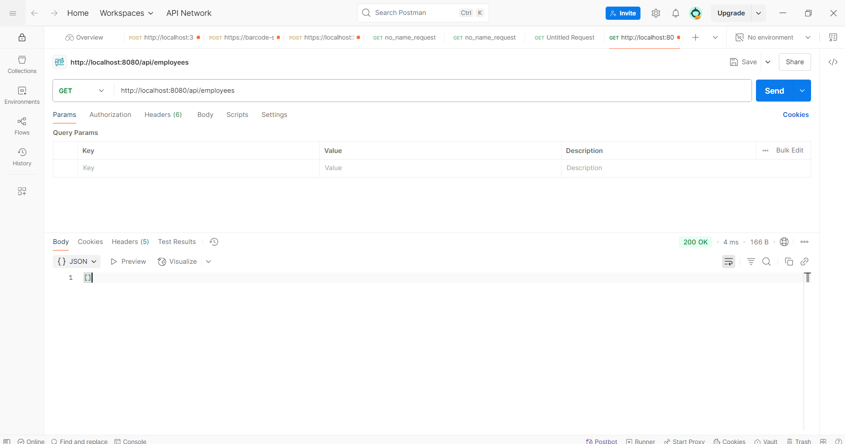

- Create REST service for department

Solution:
DepartmentController.java:
package com.example.employee_api.controller;
import com.example.employee_api.service.DepartmentService;
import org.springframework.beans.factory.annotation.Autowired;
import org.springframework.web.bind.annotation.*;
import java.util.List;
@RestController
@RequestMapping("/api")
public class DepartmentController {
@Autowired
private DepartmentService departmentService;
@GetMapping("/departments")
public List<String> getAllDepartments() {
System.out.println("/departments endpoint called");
return departmentService.getAllDepartments();
}
}
DepartmentDao.java:
package com.example.employee_api.dao;
import org.springframework.context.support.ClassPathXmlApplicationContext;
import org.springframework.stereotype.Repository;
import java.util.ArrayList;
import java.util.List;
@Repository
public class DepartmentDao {
private static List<String> DEPARTMENT_LIST = new ArrayList<>();
public DepartmentDao() {
try {
ClassPathXmlApplicationContext context =
new ClassPathXmlApplicationContext("employee.xml")
DEPARTMENT_LIST = (List<String>) context.getBean("departmentList");
System.out.println("Loaded Departments: " + DEPARTMENT_LIST);
} catch (Exception e) {
System.out.println("Failed to load departmentList from XML");
e.printStackTrace();
}
}
public List<String> getAllDepartments() {
return DEPARTMENT_LIST;
}
}
DepartmentService.java:
package com.example.employee_api.service;
import com.example.employee_api.dao.DepartmentDao;
import org.springframework.beans.factory.annotation.Autowired;
import org.springframework.stereotype.Service;
import java.util.List;
@Service
public class DepartmentService {
@Autowired
private DepartmentDao departmentDao;
public List<String> getAllDepartments() {
return departmentDao.getAllDepartments();
}
}

Output:
